TEST PLAN

- Create a Student object with the default constructor

- Create a Student object with all non-default constructor

- Test all get methods
  - getName
  - getPhoneNo
  - getSubject
  - getStore

first positv than negative tests

- test all set Methods
  - setName
  - setPhoneNo
  - setSubject

- Test display methods

Student

name: string
phoneNo: string
subject: string

student()
student(String, String, String)
display()
getName(): String
getPhoneNo(); String
getSubject(): String
getStore(): String
setName(String)
setPhoneNo(String)
setSubject(String)

ACTUAL TEST

Test 1
Create a Student object with the default constructor

Test Data
- No input

Expected Results:
- name: “student”
- phoneNo: “999999999”
- subject: “subject”

Actual Result:

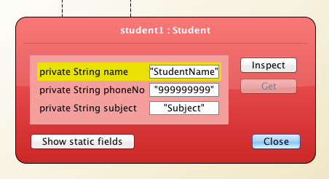

Test 2

Create a Student object with all non-default constructors

Test Data
- name: Andy Cheng
- phoneNo: 987654321
- subject: Computing

Expected Results:
- name: “Andy Cheng”
- phoneNo: “987654321”
- subject: “Computing”

Actual Result:

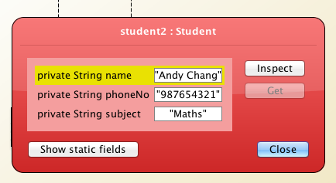

Test 2 b) Negative testing

Create a Student object with invalid attributes where possible

- name cant be blank
- phone number has to start with a 9
- phone number has to be 9 digits long
- subject can only be on of the 3

Testing Blank Name

Test Data
- name: “ ”
- phoneNo: “998877665”
- subject: “Maths”

Expected Results:
- name: “student Name”
- phoneNo: “998877665”
- subject: “Maths”

Actual Result:

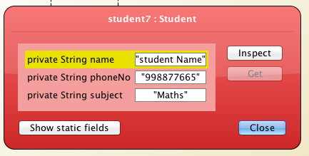
Testing Blank wrong numbers

With 8 digits

Test Data
- name: “Andy Cheng”
- phoneNo: “99887766”
- subject: “Maths”

Expected Results:
- name: “student”
- phoneNo: “999999999”
- subject: “Maths”

Actual Result:

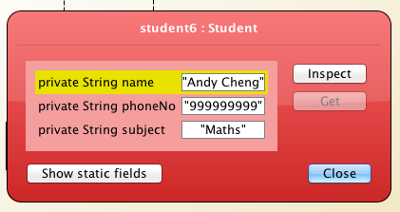

With 10 digits

Test Data
- name: “Andy Cheng”
- phoneNo: “9988776655”
- subject: “Maths”

Expected Results:
- name: “student”
- phoneNo: “999999999”
- subject: “Maths”

Actual Result:

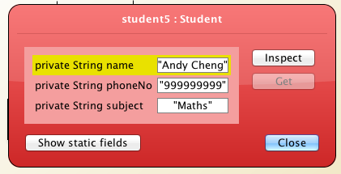

Testing Blank false number not beginning with 9

Test Data
- name: “Andy Cheng”
- phoneNo: “887766554”
- subject: “Maths”

Expected Results:
- name: “student”
- phoneNo: “887766554”
- subject: “Maths”

Actual Result

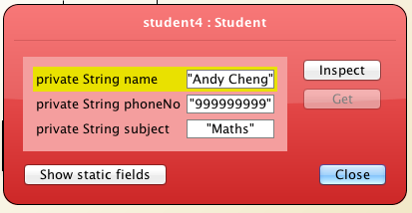

Testing with letter instead of number

Test Data
- name: “Andy Cheng”
- phoneNo: “a”
- subject: “Maths”

Expected Results:
- name: “student”
- phoneNo: “999999999”
- subject: “Maths”

Actual Result:

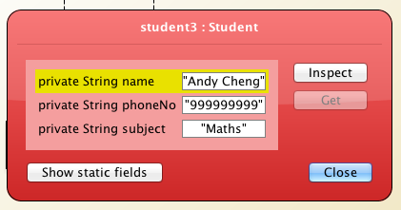

Testing wrong subject (Sport)

Test Data
- name: “andy”
- phoneNo: “998877665”
- subject: “sport”

Expected Results:
- name: “andy”
- phoneNo: “998877665”
- subject: “subject”

Actual Result:
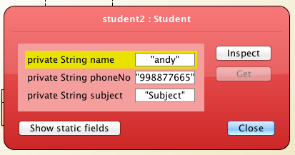

Test 3

Test all get Methods

  - getName

test Data
- no data

Expected result:

Return the default constructor name which is “StudentName”

Actual Result:

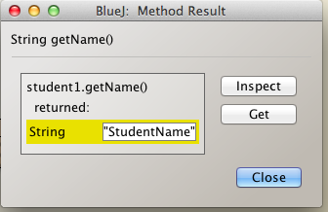

getPhoneNo

test Data
- no data

Expected result:

Return the default constructor phoneNo which is “999999999”

Actual Result:

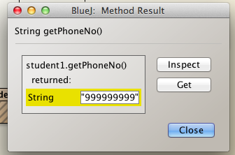

getSubject

Test data
- no data

Expected result:

Returns the default constructor subject with is “subject”

Actual Result:

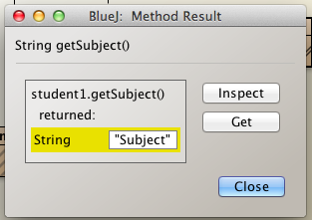

  - getStore

Test Data
- no data

Expected result:

Returns a string with the default constructor
“StudentName, 99999999, Subject”

Actual Result:

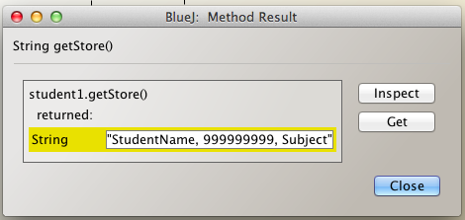

Test 4

Test all set Methods

- setName

Test data
- Set name “andy”

Expected result:

Name string: “andy”

Actual Result:

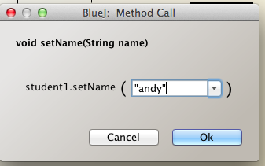
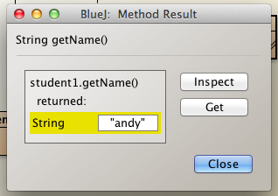

- setPhoneNo

Test Data
- set phoneNo to 998877665

Expected result:
String : “998877665”

Actual Result:

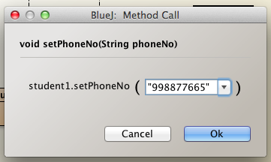

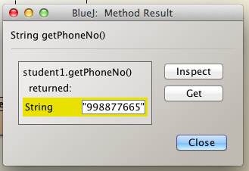

- setSubject

Test Data

- set subject to Maths

Expected result:

String : “Maths”

Actual Result:

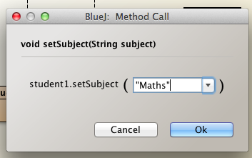

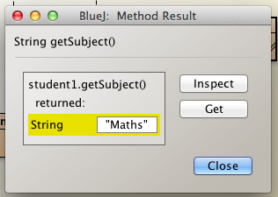

Negative-get-Testing

Testing Blank Name

Test Data
- setName: “”

Expected Results:
- getName: “student Name”

Actual Result:

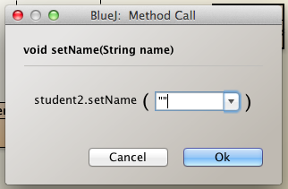

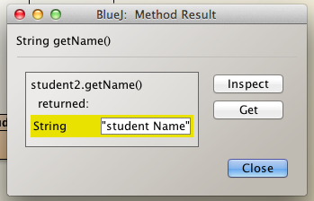

Testing Space as Name

Test Data
- setName: “”

Expected Results:
- getName: “student Name”

Actual Result:

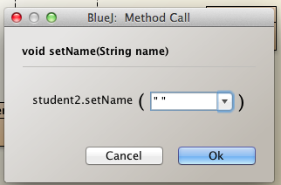

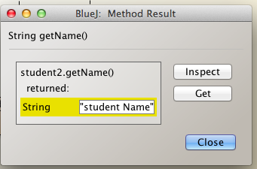

Testing 8 digits phoneNo

Test Data
- setPhoneNo: “99887766”

Expected Results:
- getPhoneNo: “999999999”

Actual Result:

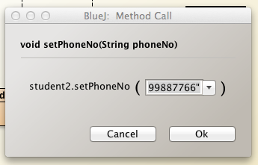
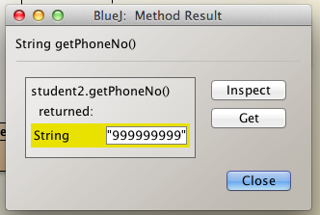

Testing 10 digits phoneNo

Test Data
- setPhoneNo: “9988776655”

Expected Results:
- getPhoneNo: “999999999”

Actual Result:

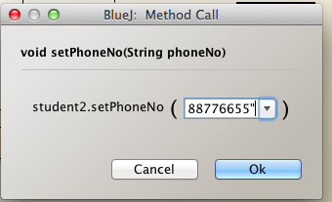
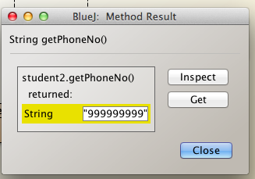

Testing empty phoneNo

Test Data
- setPhoneNo: “”

Expected Results:
- getPhoneNo: “999999999”

Actual Result:

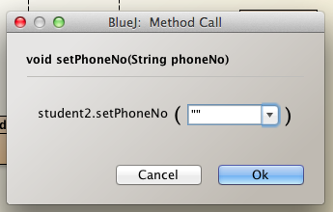

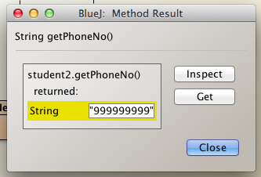

Testing letters as phoneNo

Test Data
- setPhoneNo: “jash”

Expected Results:
- getPhoneNo: “999999999”

Actual Result:

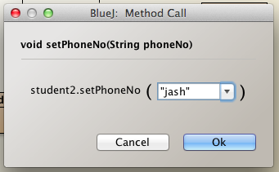

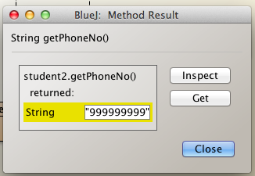

Testing starting number that is not 9 as phoneNo

Test Data
- setPhoneNo: “887766554”

Expected Results:
- getPhoneNo: “999999999”

Actual Result:

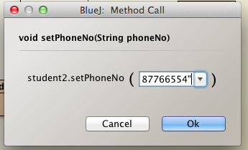

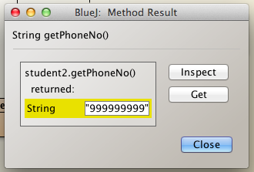

Testing empty subject

Test Data
- setSubject: “”

Expected Results:
- getSubject: “subject”

Actual Result:

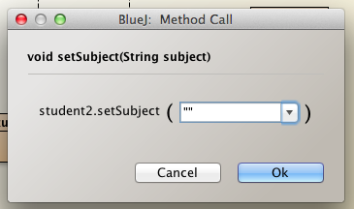

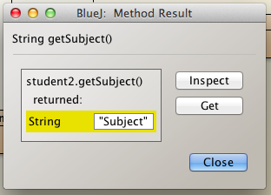

Testing subject that’s not existing (Maths,Englisch,Computing)

Test Data
- setSubject: “sport”

Expected Results:
- getSubject: “subject”

Actual Result:

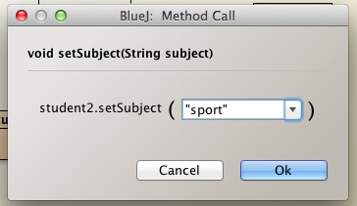

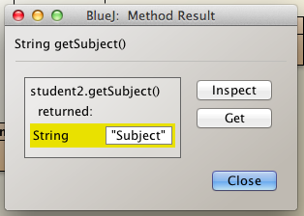

Test 5

Test Display Method

Test Data
- no test data

Expected result

- Start the terminal and display the default values
  - Student name: StudentName
  - Student number: 999999999
  - Subject: Subject

Actual Result

